**Smart Farmer-IOT Enabled Smart Farming Application**

**SPRINT DELIVERY – 3**

|  |  |
| --- | --- |
| TITLE | Smart Farmer-IOT Enabled Smart Farming  Application |
| DOMAIN NAME | INTERNET OF THINGS |
| TEAM ID | PNT2022TMID19661 |
| LEADER NAME | BHOOPESH R K |
| TEAM  MEMBERS  NAME | AMITKUMAR SHARMA R  GAUTAM KUMAR RAI D  KAMALI K |

**Configuration of Node-Red to send commands to IBM cloud**

ibmiot out node I used to send data from Node-Red to IBM Watson device. So, after

adding it to the flow we need to configure it with credentials of our Watson device.

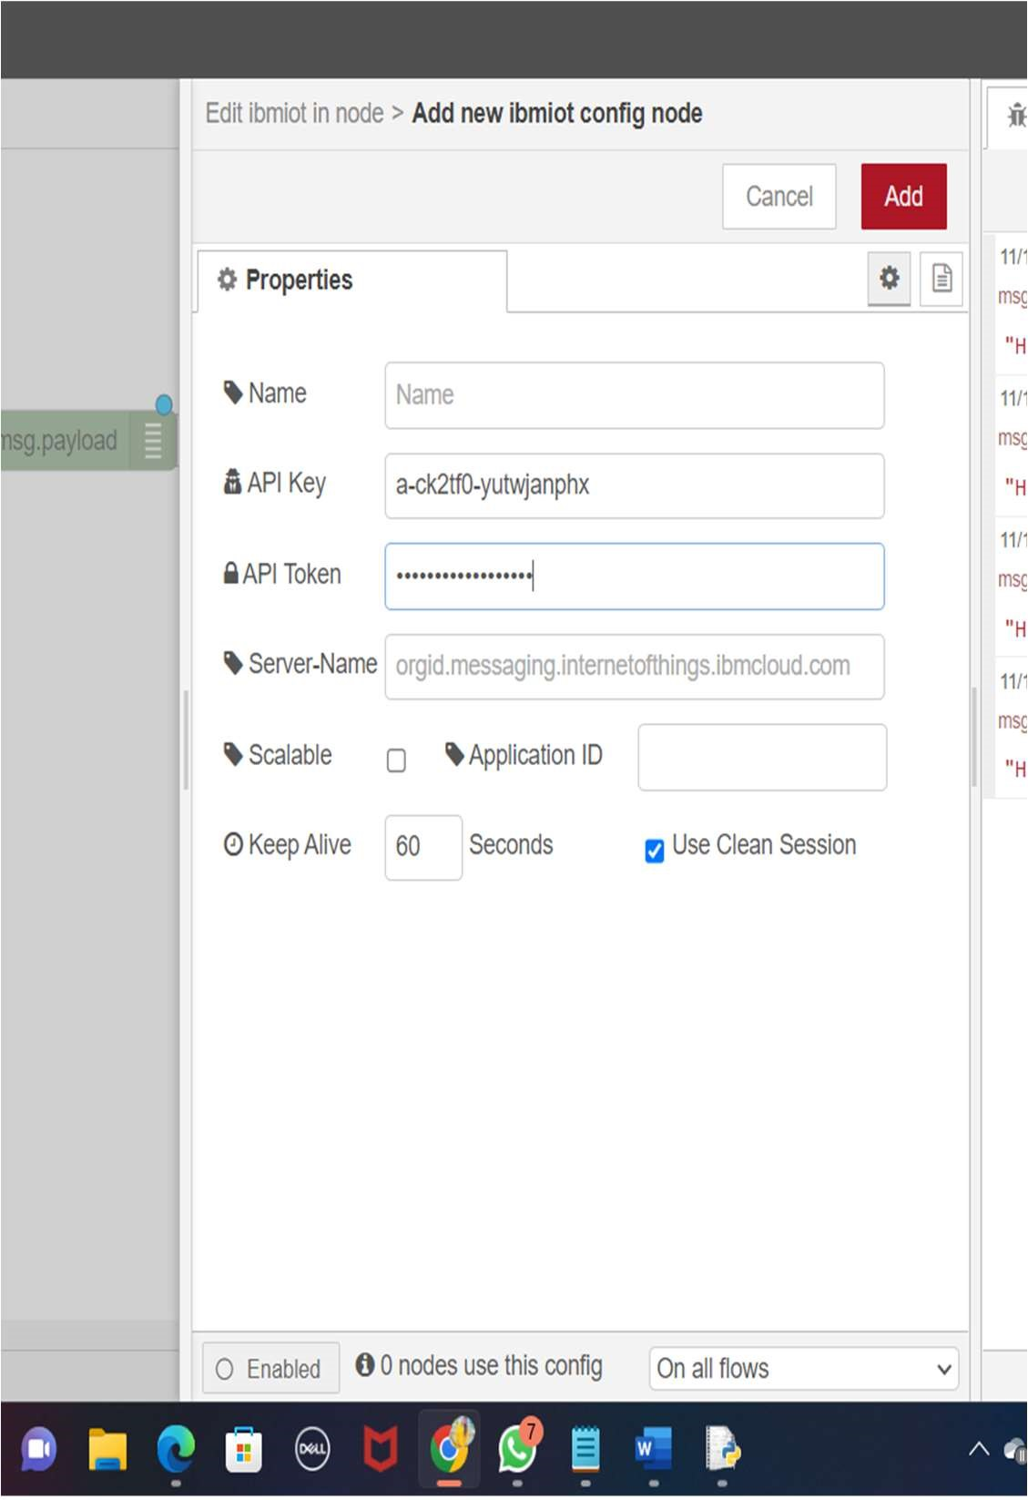

Here we add two buttons in UI

1. -> for motor on
2. -> for motor off

We used a function node to analyses the data received and assign command to each number.

The Java script code for the analyses is: if(msg.payload===1) msg.payload={"command”: “ON"};

else if(msg.payload===0)

msg.payload={"command”: “OFF"};

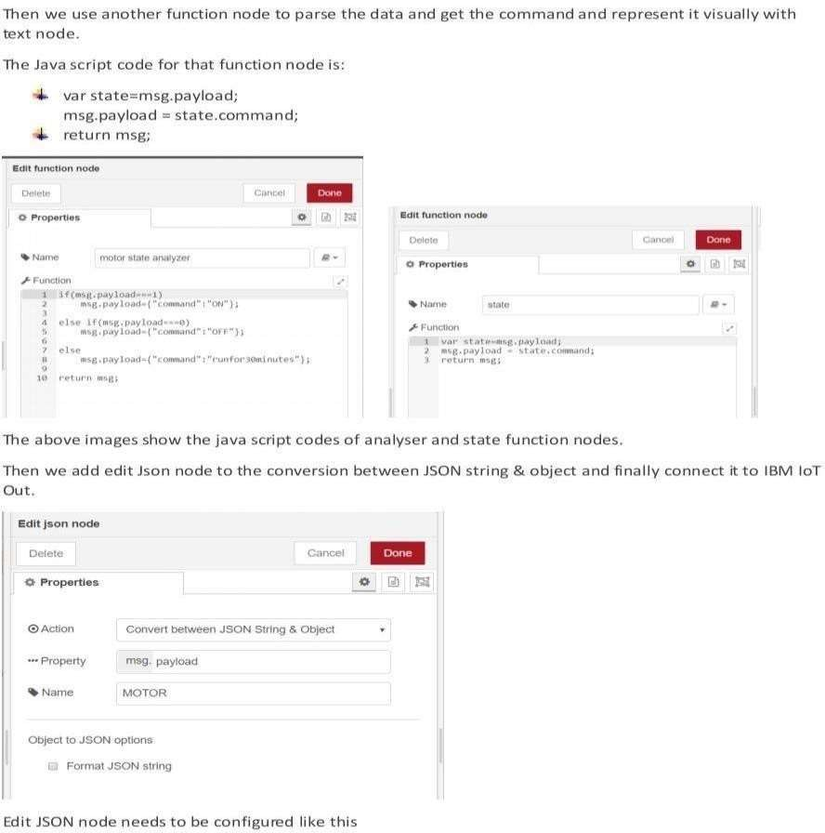

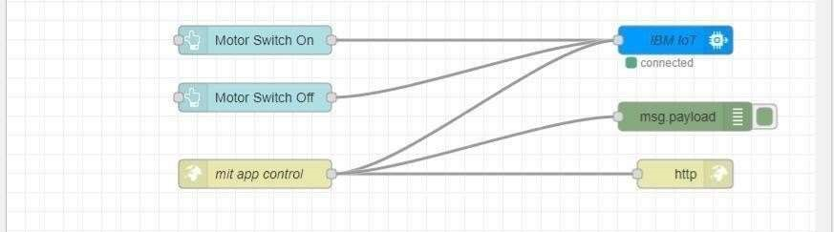

This is the program flow for sending commands to IBM cloud.

Adjusting User Interface

In order to display the parsed JSON data a Node-Red dashboard is created

Here we are using Gauges, text and button nodes to display in the UI and helps to monitor the parameters and control the farm equipment.

Below images we started to create the flow 1

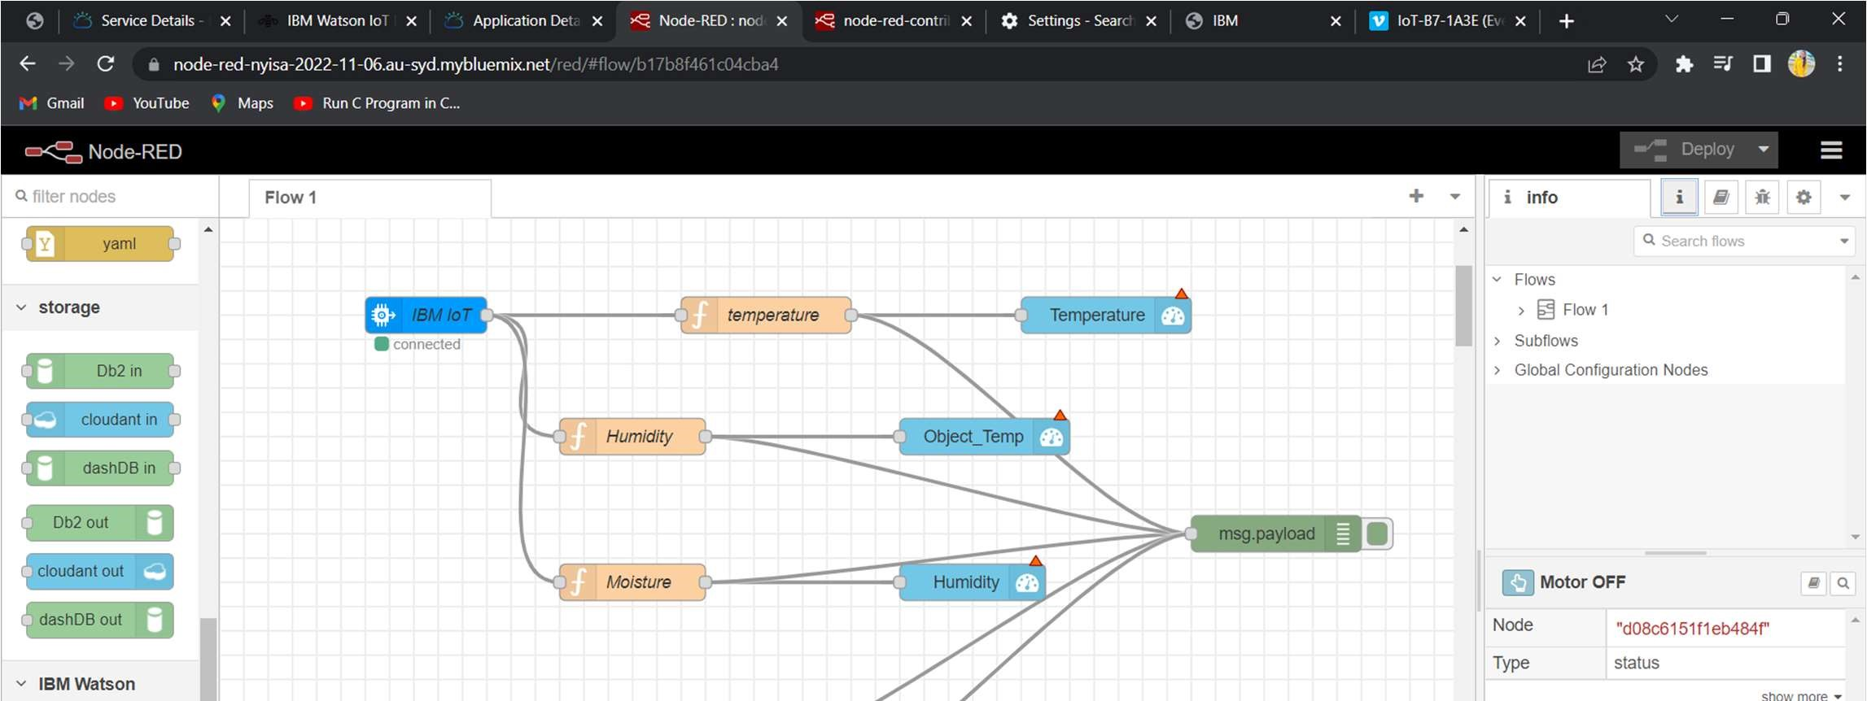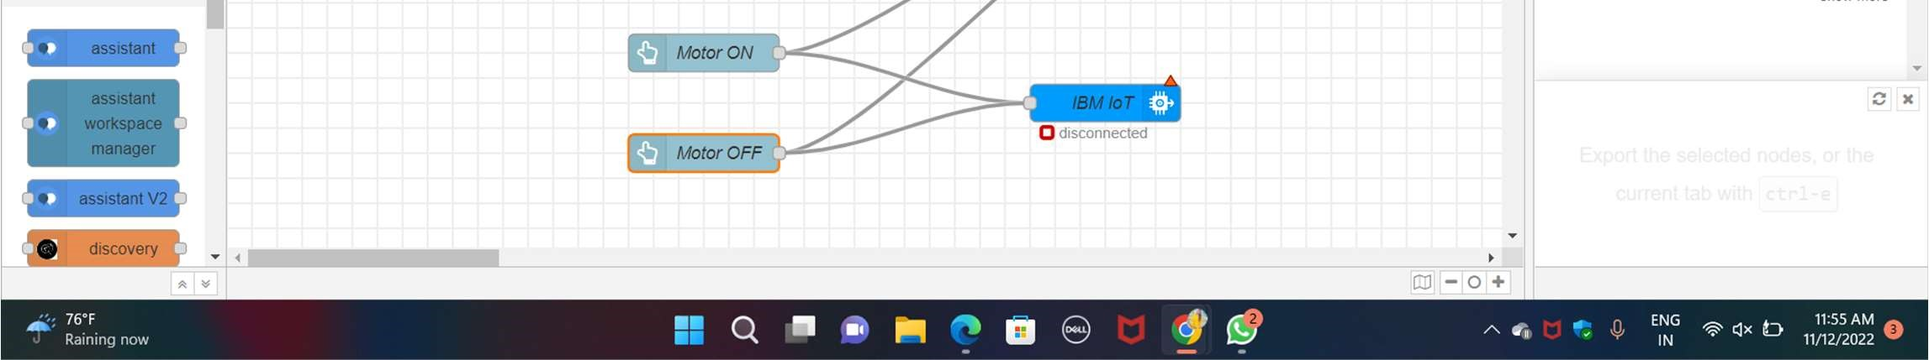

COMPLETE PROGRAM FLOW :

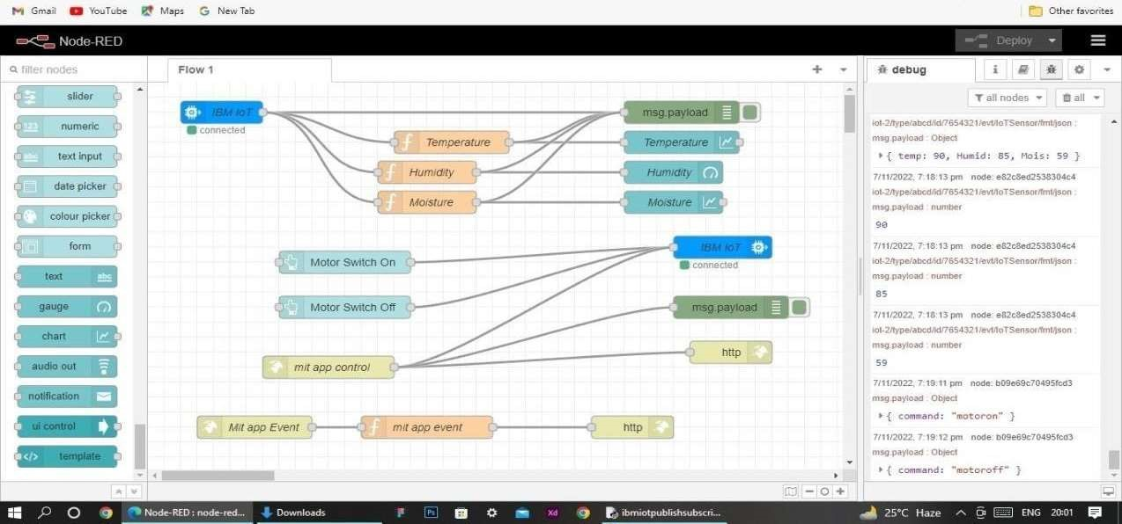

MOBILE APP WEB :

BLOCK DIAGRAM

